Emergency Plan

IN A MEDICAL EMERGENCY, INCLUDING A CREW MEMBER BEING TAKEN SERIOUSLY ILL OR BECOMING UNRESPONSIVE, IMMEDIATELY:

Raise the Alarm with a launch or with other boats if available. All crews are advised to ensure they carry a mobile phone when on the water.

Use a cell phone to dial for emergency assistance 999;
OR if no cell phone available row to the nearest location where a safe landing can be made, get to a telephone, and make a 999 call, indicating the closest access location from the list below:

If the location is close to the boathouse:
Boathouse address: Shiplake College Boathouse, Henley On Thames, Oxfordshire, RG9 4BW
Send two adult helpers to direct emergency services. One to wait by St Peters and St Pauls Church and the other to wait at the A4155 and Church Lane junction.

If the location is close to St Patrick’s stream: Milestone Ave, Charvil, Reading RG10 9TN
Make sure a launch driver is stationed near the houses to raise the alarm.

If the location is closer to Sonning Bridge:
Sonning Bridge area: Near to the Coppa Club, The Great House, Thames Street, Sonning on Thames, West Berkshire, RG4 6UT
Make sure a launch driver is at Sonning bridge to meet the emergency services.

MAP OF THE AREA AROUND THE BOATHOUSE:
Boathouse address: Shiplake College Boathouse, Henley On Thames, Oxfordshire, RG9 4BW
Send two adult helpers to direct emergency services. One to wait by St Peters and St Pauls Church and the other to wait at the A4155 and Church Lane junction.

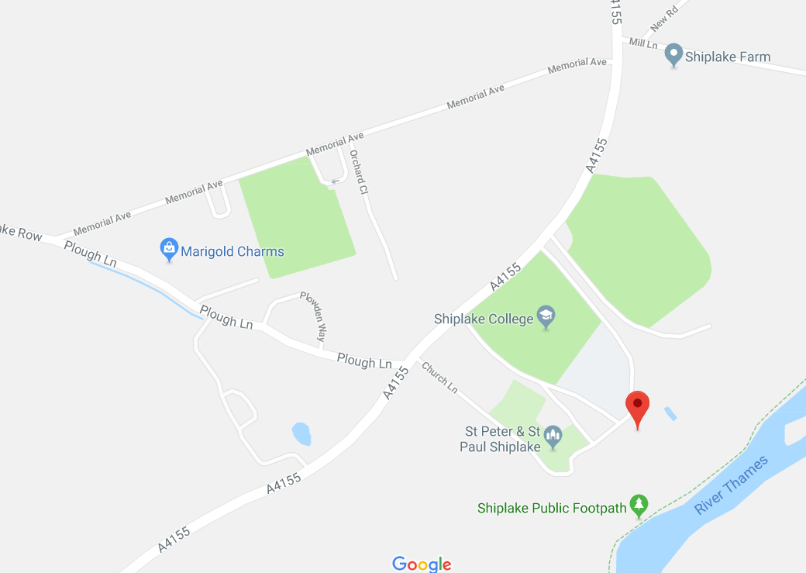

MAP OF THE AREA AROUND ST PATRICK’S STREAM:
If the location is close to St Patrick’s stream: Milestone Ave, Charvil, Reading RG10 9TN
Make sure a launch driver is stationed near the houses on the river bank to raise the alarm.

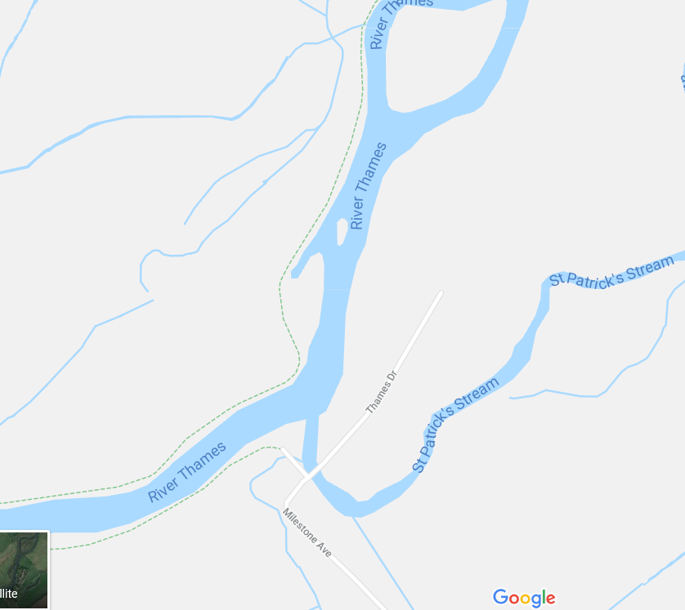

MAP OF THE AREA AROUND SONNING BRIDGE:
Sonning Bridge area: Near to the Coppa Club, The Great House, Thames Street, Sonning on Thames, West Berkshire, RG4 6UT
Make sure a launch driver is at Sonning bridge to meet the emergency services.

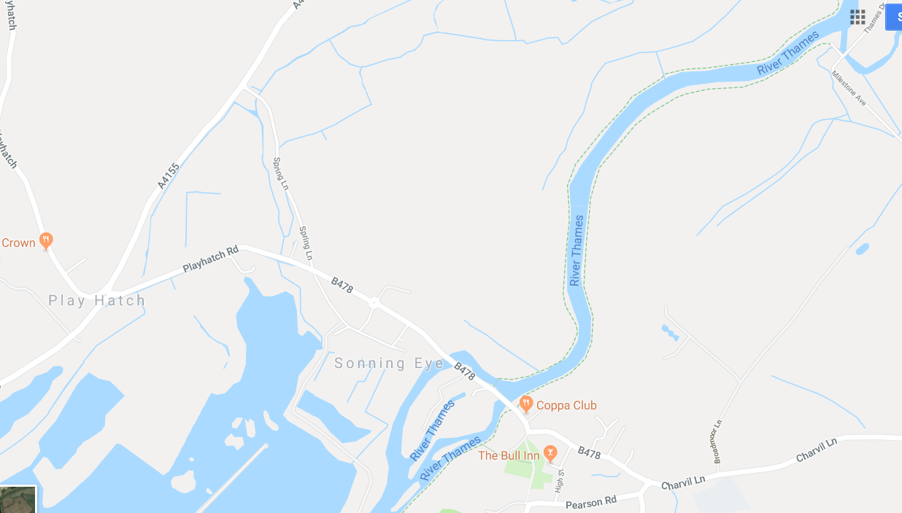

Taking charge of the situation:

Where possible, the relevant squad coach, crew coach or co-ordinator shall take charge of any incident; other members present should make themselves available to assist on request rather than acting independently. No-one should leave the site of an incident until it is resolved, unless they are asked to do so (e.g. to fetch help). ASSEMBLY POINT: area between the sculling shed and dry boathouse.
First aid and defibrillator
- There are well-stocked first aid kits in The Club caravan (behind large boat store), including a thermal blanket. Bruce Gascoine and Nicola Lee have keys to this.
- Coaches launches have first aid kits including thermal blankets.
- An AED (automated external defibrillator) is located at the base of the stairs to the Club House. In case of possible heart failure, open the lid, turn it on and follow the instructions. The victim and rescuer must be dry and on a solid surface for the AED to be used.
- In the event the casualty is wet, towel them and start the process immediately.

In the rather particular case of a cox needing CPR, the first aider will need to know how to deflate the patient's lifejacket first: the "oral" inflation tube on the left-hand side will have a valve in it: open it by turning the stopper back to front and pressing it into the tube. (Or maybe slice it with a knife, but only if there is NO chance of falling back in the water!)

Further CPR advice and tips can be found here:
http://www.sja.org.uk/sja/first-aid-advice/first-aid-techniques/resuscitation-cpr.aspx

A report of any incident (including date, time, location and all those involved) shall be made using the British Rowing online incident reporting form: http://incidentreporting.britishrowing.org/?q=incidentreporting

Contact details:
Shiplake Vikings first aiders:

Wendy Fry: 0782 788 3039
Bruce Gascoine: 0780 171 0211
Mark Hatlee: 0786 018 7186

Coaches contact details (note that all coaches should have these details recorded on their contacts):

Gascoine | Bruce | 0780 171 0211
Mark | Hatlee | 0786 018 7186
Fry | Wendy | 0782 788 3039

Shiplake College contact details in event of an emergency:
Should you have any requirement for maintenance and/or security assistance between the hours of 1700 and 0800 Monday to Friday, or throughout the weekend:
- Call 07710 071928 and speak to the Duty person
- Where appropriate they will react as the first responder to assist and advise you (initial response should be within 30mins)
- Speak to the club’s Safety office, Mr Nick Rosi on 07393 572382.

Other useful numbers:

Royal Berkshire Hospital: Tel: 0118 322 5111
Address: London Road, Craven Road, Reading, Berkshire, RG1 5AN
Website: http://www.royalberkshire.nhs.uk
Email: NHS.Choices@royalberkshire.nhs.uk

MINOR INJURIES ONLY - NO A/E
Townlands Memorial Hospital - Oxford Health NHS Foundation Trust
Tel: 01865 903703
Address: York Road, Henley-on-Thames, Oxfordshire, RG9 2E

NHS 111
Is the non-emergency number and will connect you to a highly trained adviser, supported by healthcare professionals. NHS 111 is available 24 hours a day, 365 days a year.
You should use the NHS 111 service if you urgently need medical help or advice but it's not a life-threatening situation.

Call 111 if:

you need medical help fast but it's not a 999 emergency

you think you need to go to A&E or need another NHS urgent care service

you don't know who to call

you need health information or reassurance about what to do next

NHS 111 will ask you questions to assess your symptoms, then give you the healthcare advice you need or direct you to the local service that can help you best.

Where possible, the NHS 111 team will book you an appointment or transfer you directly to the people you need to speak to.

Emergency Action Plan

STRONG RECOMMENDATIONS:
- Do not go out rowing alone, ever, when the water temperature is below 10 degrees C. Hypothermia is deadly quick at lower temperatures.
- Always row with at least one other boat, or with the coach/safety boat.
- Always have your mobile phone with you if there is no coach boat, so that you can call 999 for help. Keep it in a zip-lock bag, then it won't sink!
Everyone can call for emergency services via SMS text message, and as rowers in a quiet part of the river this is mandatory. Your phone must be registered first:
- Text "register" to 112;
- read the response;
- text "yes" to 112.
All coaches should register in this way.

In the event of a capsize:

If you fall into very cold water, EXPECT your breath to be taken away - BUT DO NOT PANIC: If you can keep calm for just 90 seconds, you will be in much better shape.
- If out of your depth & unable to wade ashore, hold onto the capsized hull as a buoyancy aid & attempt to swim it to shore.
- If the water is cold, get as much of your body out of the water as soon as possible, draping yourself over the upturned hull (if necessary turning over the hull for this purpose).
- If possible, "buddy-up"; holding on to each other until rescued to provide mutual warmth and support and to help ensure all are accounted for.
- Other boats in the vicinity should fetch help or a launch if one is available. DO NOT ATTEMPT TO RESCUE FROM ANOTHER ROWING SCULL - you are likely to tip over, putting more people in the water with no one to get help.

Possible serious incidents associated with rowing
The following gives guidance for recognizing and treating possible serious incidence associated with rowing.

For those assisting, as a guide to reducing the risks of hypothermia, you have about 10-15 minutes to get a rower out of the water in summer months and 5-10 minutes in the colder winter months.

There are three stages to take note of:
Cold Water Shock (0-3 minutes) – in the first minutes the rower will be gasping for air and may seem disorientated. First actions are to make contact with the rower, offer reassurance and ask them to hold onto the boat. If there are signs of injury, or concussion then using the throw line is an option and phoning for support e.g. coach, club launch and emergency services.
Swim Failure (3-15 minutes) – as the water takes the heat away from the body, the ability to swim and self-help is reduced. Encourage the rower to right the boat, by standing on the nearest rigger and reaching across as the boat rolls over. Give instructions clearly, calmly and in small doses. Some rowers might be able to climb back into the boat unaided and row back to the clubhouse. If not, ask them to swim with the boat to the bank so that they can be assisted (and to get back into the boat, if appropriate). This latter course of action is advised.
Hypothermia (15-30 minutes) - immersion for a long time leading to collapse. Encourage the rower to stop moving to conserve heat and bring the knees into the body, or huddle with other crew members. Aim to get them out of the water as quickly as possible, and once on land, keep the rower in a horizontal position and apply extra layers while help arrives

Hypothermia
The symptoms of hypothermia depend on how cold the environment is and how long you are exposed for. Severe hypothermia needs urgent medical treatment in hospital. Shivering is a good guide to how severe the condition is. If the person can stop shivering on their own, the hypothermia is mild, but if they cannot stop shivering, it is moderate to severe.
Mild cases
In mild cases, symptoms include:
- shivering,
- feeling cold,
- low energy,
- discomfort at higher temperatures than normal, or
- cold, pale skin.
Moderate cases
The symptoms of moderate hypothermia include:
- violent, uncontrollable shivering,
- being unable to think or pay attention,
- confusion (some people don't realise they are affected),
- loss of judgment and reasoning,
- difficulty moving around or stumbling (weakness),
- feeling afraid,
- memory loss,
- fumbling hands and loss of coordination,
- drowsiness,
- slurred speech,
- listlessness and indifference, or
- slow, shallow breathing and a weak pulse.
Severe cases
The symptoms of severe hypothermia include:
- loss of control of hands, feet, and limbs,
- uncontrollable shivering that suddenly stops,
- unconsciousness,
- shallow or no breathing,
- weak, irregular or no pulse,
- stiff muscles, and
- dilated pupils.
Although hypothermia is defined as occurring when the body temperature drops below 35°C (95°F), mild hypothermia can start at higher body temperatures.
As the body temperature decreases further, shivering will stop completely. The heart rate will slow and a person will gradually lose consciousness. When unconscious, a person will not appear to have a pulse or be breathing. Emergency assistance should be sought immediately and CPR provided while the person is warmed. CPR is an emergency procedure, consisting of 30 chest compression followed by 2 rescue breaths.

Treating hypothermia
As hypothermia can be a life-threatening condition, seek medical attention as soon as possible.
Hypothermia is treated by preventing further heat being lost and by gently warming the patient.
If you are treating someone with mild hypothermia, or waiting for medical treatment to arrive, follow the advice below to prevent further loss of heat.
Things to do for hypothermia:
- Move the person indoors, or somewhere warm, as soon as possible.
- Once sheltered, gently remove any wet clothing and dry the person
- Wrap them in blankets, towels, coats (whatever you have), protecting the head and torso first
- Your own body heat can help someone with hypothermia. Hug them gently
- Increase activity if possible, but not to the point where sweating occurs, as that cools the skin down again
- If possible, give the person warm drinks (but not alcohol) or high energy foods, such as chocolate, to help warm them up
- Once body temperature has increased, keep the person warm and dry
It is important to handle anyone that has hypothermia very gently and carefully.
Things you should NOT do:
- Don't warm up an elderly person using a bath, as this may send cold blood from the body's surfaces to the heart or brain too suddenly, causing a stroke or heart attack;
- Don't apply direct heat (hot water or a heating pad, for example) to the arms and legs, as this forces cold blood back to the major organs, making the condition worse
- Don't give the person alcohol to drink, as this will decrease the body's ability to retain heat
- Don't rub or massage the person’s skin, as this can cause the blood vessels to widen and decrease the body’s ability to retain heat. In severe cases of hypothermia there is also a risk of heart attack

Near-Drowning
The goal is to safely rescue the victim and begin first aid.
In a near-drowning emergency, the sooner the rescue and first aid begin, the greater the victim's chance of survival. Do not endanger yourself in rescuing the victim during this process.

Rescue options to reach the drowning victim in the water:
- Use a Throw Line
- Throw a rope with a buoyant object
- Use a long stick
- Bring a boat alongside the victim and tow the victim to shore. Do not haul the victim into the boat because it may cause the boat to capsize, and both of you will be in the water. Cold water may render the victim too hypothermic to grasp objects within their reach or to hold while being pulled to safety
- As a last resort, you can attempt a swimming rescue if you are sufficiently trained in water rescue. Do not attempt a rescue beyond your capabilities. Otherwise, you may harm yourself
  - For a swimming rescue, approach the person from behind while trying to calm the victim as you move closer. A panicked victim can pull you down
  - Grab a piece of clothing or cup a hand or arm under the victim's chin and pull the person face up to shore while providing special care to ensure a straight head-neck-back alignment especially if you think the person has spine injuries

First aid for a near-drowning victim
  - The focus of the first aid for a near-drowning victim in the water is to get oxygen into the lungs without aggravating any suspected neck injury.
  - If the victim's breathing has stopped, give 5 mouth-to-mouth rescue breaths as soon as you safely can. This could mean starting the breathing process in the water.
  - Once on shore, reassess the victim's breathing and circulation (heartbeat and pulse). If there is breathing and circulation without suspected spine injury, place the person in recovery position (lying on the stomach, arms extended at the shoulder level and bent, head on the side with the leg on the same side drawn up at a right angle to the torso) to keep the airway clear and to allow the swallowed water to drain. If there is no breathing, begin CPR. Continue CPR (30 chest compression followed by 2 rescue breaths) until help arrives or the person revives.
  - Keep the person warm by removing wet clothing and covering with warm blankets to prevent hypothermia.
  - Remain with the recovering person until emergency medical personnel have arrived.

